**Career Objective**

Dedicated CSE student aspiring to secure a position in web development. Proficient in React, Node, Express, MongoDB and JS with a keen interest in front-end frameworks. Aiming to contribute creativity and technical skills to design and develop user-friendly and visually appealing web applications.

**Projects**

**Website**  (Mar 2020 – Continue)

* Bus-Ticket-Pro: A ticket management system enabling customers to book tickets and select seats, with admin tools for managing buses. [Live Site](https://bus-ticket-pro.web.app/) | [Client Link](https://github.com/Reyad02/bus-ticket-pro) | [Server Link](https://github.com/Reyad02/bus-ticket-pro-server)

Key Features:

1. Book bus tickets and select available seats
2. Complete payments via SSLCommerz
3. Managebusesand observe bookings through an admin dashboard

* Device Master: Device Master is a platform for booking mobile and laptop repair services with secure payments and blog insights. [Live Site](https://device-master-2614d.web.app/) | [Client Link](https://github.com/Reyad02/device-master) | [Server Link](https://github.com/Reyad02/Device_Master_Backend)

Key Features:

1. Book repair services securely
2. Make payments with Stripe
3. Admin can add and publish helpful blogs

**Hardware**  (Mar 2020 – Continue)

* IT Component Lender: In IT Component Lender, students can borrow electronic components and return them later. During the return process, the system performs image processing to verify. Report link: <https://drive.google.com/file/d/1cCEScKhFUy9fvvXpw1nZ68lelus1cj-E/view?usp=sharing>
* Smart Football Stadium: The Smart Football Stadium is an automated venue featuring automatic lighting, field covering during rain, and in-stadium beverage services, among other functionalities. Report link: <https://drive.google.com/file/d/1P1Yagq4eaBB_5nrqya_B_TxFUCa5sZrL/view?usp=sharing>

**Achievements & Certification**

* Intra University AI Contest (Fall 2022), 1st Runner-up
* CSE Project Show (Fall 2022) - Database Management System, 1st Runner-up [Project - Cafeteria]
* CSE Project Show (Summer 2022) Electronics Laboratory, 2nd Runner-up [Project - Smart Football Stadium]
* CSE Project Show (Spring 2023) - Microprocessor and Microcontroller Laboratory, Champion [Project - IT Component Lender]
* CSE Project Show (Fall 2023) - Final Year Design Project-1 (poster Presentation), 2nd Runner-up
* Complete Web Development Course - Programming Hero

**Publications**

* E-MedViTR: Enhanced Vision Transformers with Registers for Biomedical Image Classification ([IEEE Xplore](https://ieeexplore.ieee.org/document/10534573)). 2024 6th International Conference on Electrical Engineering and Information & Communication Technology (ICEEICT)

**Al-Momen Reyad**

Student | Web Developer

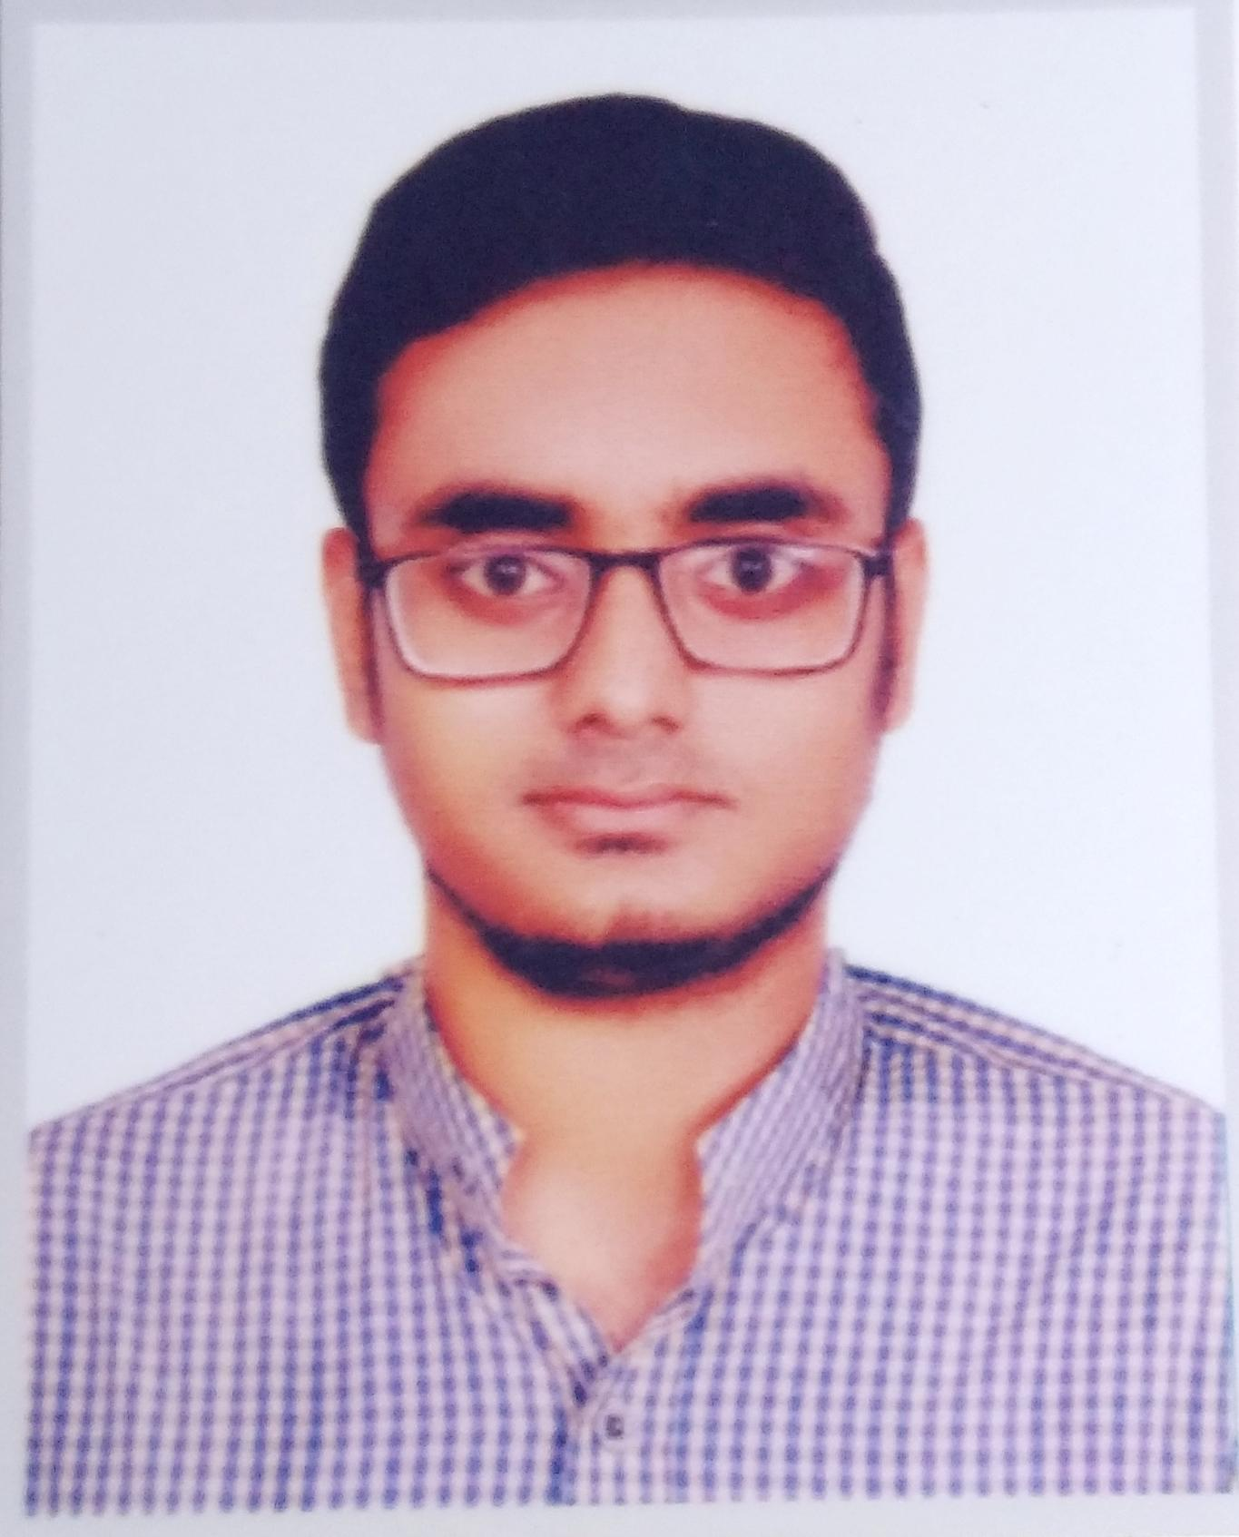

**Contact Info**

+8801521766535

almomenreyad@gmail.com

House:17, Road:1,

Block: A, Banasree

**Education Information**

B.Sc. in Computer Science and Engineering

United International University

Year: 2020-on going

Result: 3.86

HSC

Engineering University School and College

Science

Year: 2019

GPA: 4.90

SSC

Shanarpar Sheikh Mortoza Ali High School

Science

Year: 2017

GPA: 5.00

**Expertise**

HTML

CSS

JAVASCRIPT

C++

PYTHON

**Language**

Bengali: Native & Bilingual

English: Good Proficiency

**Personal Info**

Birth: 03rd November 2002

Nationality: Bangladeshi